DF Assignment 6: Fergus File Carving
Name: Che Yu Chan
Method
I opened the provided Fergus image and checked the end of the file in hex using GHex. I looked for the normal JPEG end marker, FF D9. I then checked the bytes after that marker for another file signature.
I found FF D9 at offsets 310,297–310,298. The next bytes, starting at offset 310,299, were %PDF-, which is the beginning of a PDF file. I carved everything from offset 310,299 to the end of the original image into a separate PDF. I used file and pdfinfo to check that the recovered file was a real PDF.
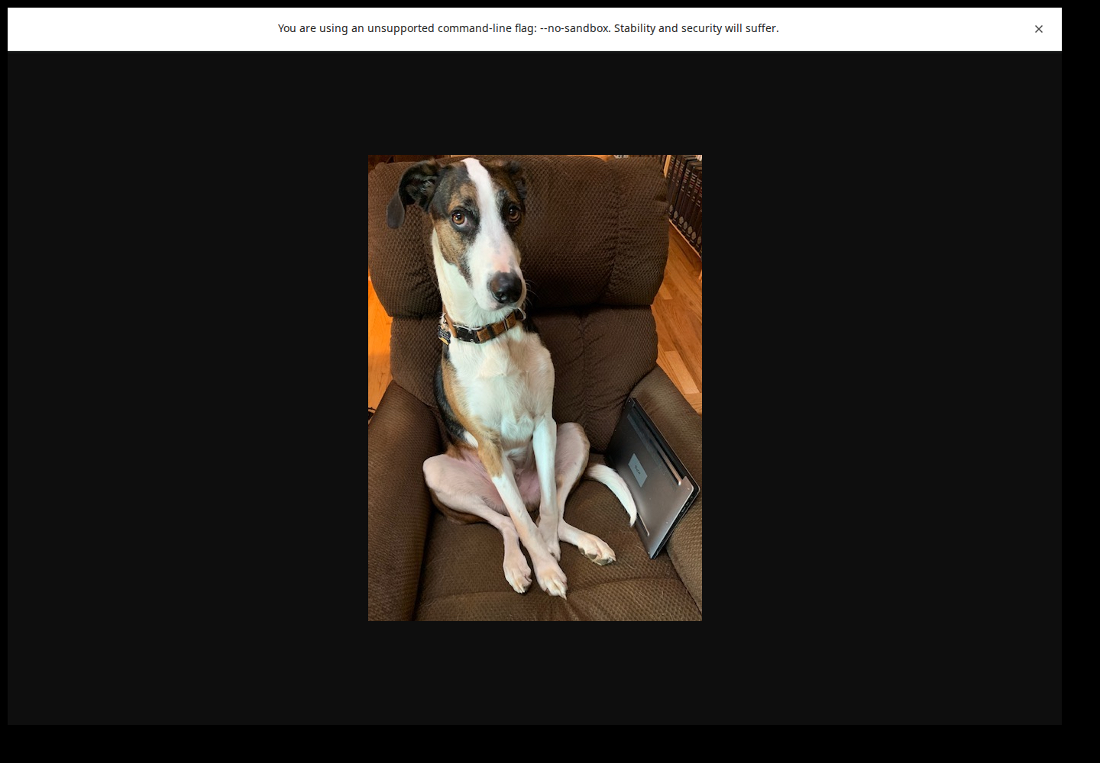

What I found in hex
The red boxes below show the two signatures used for carving. The JPEG file ends at FF D9. Right after it, the PDF file begins with %PDF-. This means extra data was added after the JPEG had already ended.
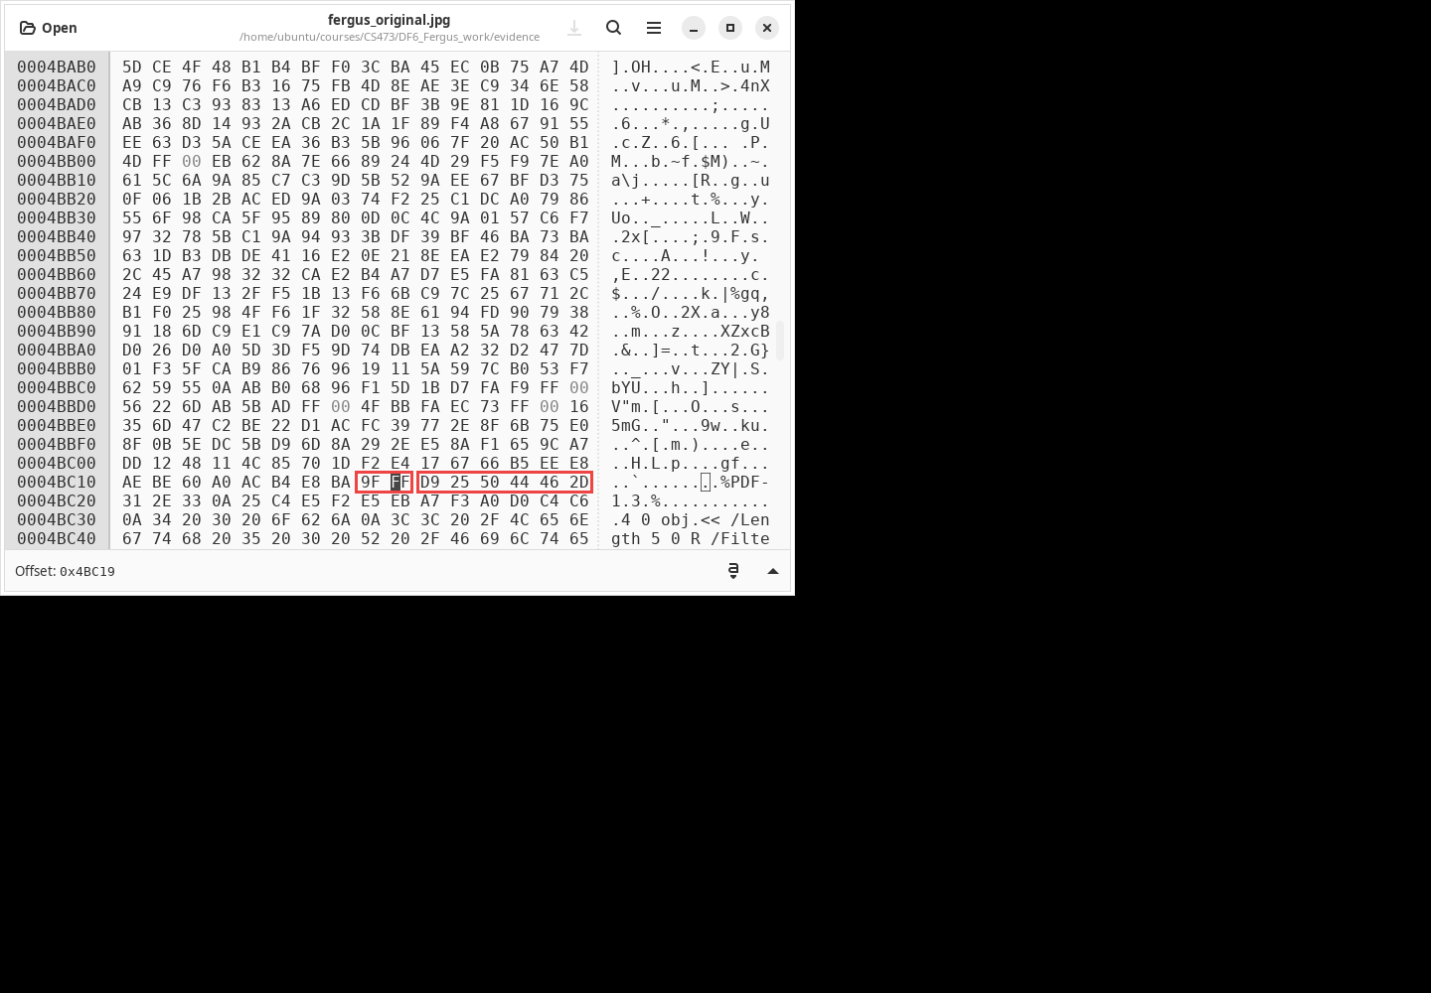
File comparison
File | Size | What I found
Original image | 523,648 bytes | JPEG image, 437 × 611 pixels. It displays the Fergus picture, but it also has extra data after the normal JPEG ending.
Carved image part | 310,299 bytes | Valid JPEG image. This is the visible dog picture.
Carved hidden file | 213,349 bytes | Valid one-page PDF. Its text says, “This is my dog Fergus.”

Recovered hidden file
After carving the PDF, I opened it in Chromium. It opened normally as a one-page PDF, so the data after the JPEG end marker was not random data. It was a separate hidden PDF file.
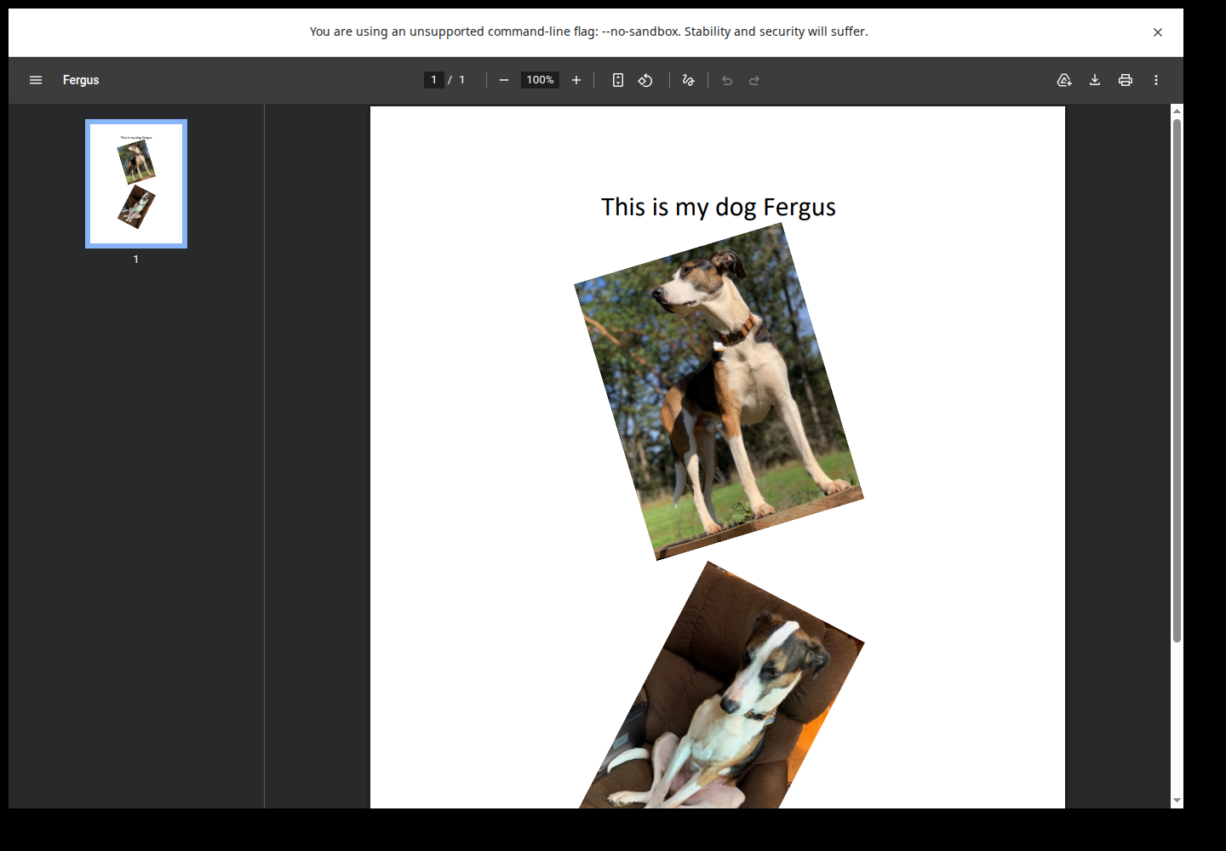
What this means
The original file was not only a JPEG. It had a PDF appended after the JPEG end marker. Looking at the file signatures made it possible to find the boundary and carve the PDF out of the image.
BTW: Fergus is really cute!

